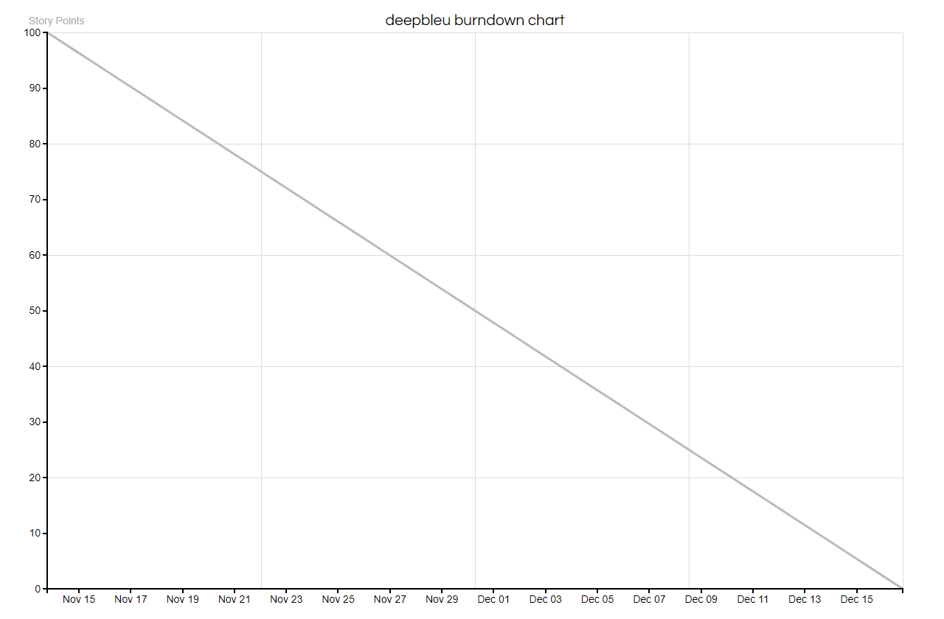
Migrate to Eclipse
Remove GUI From Server
Android ChessBoard
Serverside Save States
Player Stats
Authentication
(serverside)
PC Client Networking
SQLite JDBC
New User Registration
Android Login Screen
Gameplay API

